econ report v2025_09_18

## Quarto

xxxzaa

## Trip Volume

When you click the **Render** button a document will be generated that includes both content and the output of embedded code. You can embed code like this:’

test

1 + 1

[1] 2

You can add options to executable code like this

[1] 4

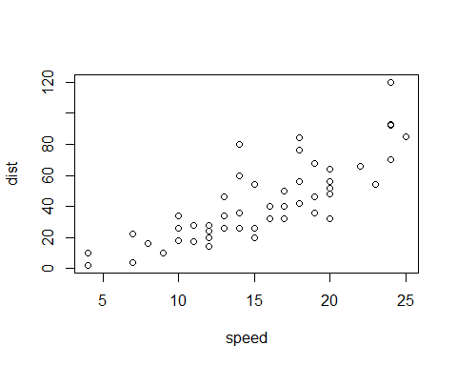

The echo: false option disables the printing of code (only output is displayed).